Machine Learning Final Review

Decision Trees

* Pure leaves
  + All either okay or Good
  + Can be fully classifiable
  + Impunity measure is 0
* Mixed
  + Need to split further
* How to make a tree
  + Keep splitting until all the leaves are pure
    - Sometimes not actually be possible
  + Organization of the data as a classifier.
  + When using a test example, we follow the tree from root down to the leaf and return the label
* Impunity
  + 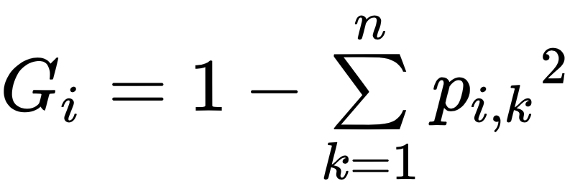
  + 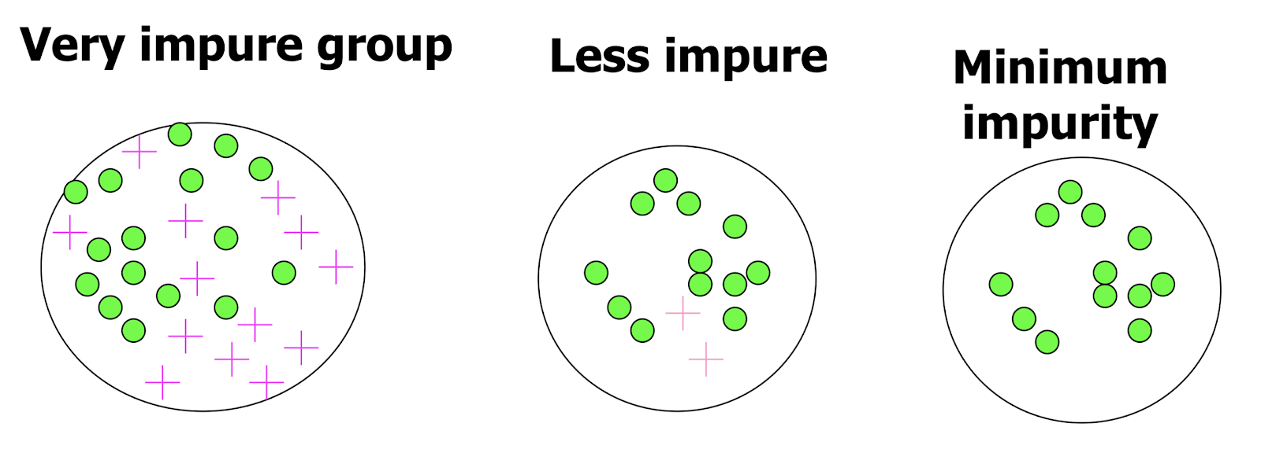
  + How you compute Gini is get the number of samples and how many samples were classified into each class
    - Then it will be 1 – ((p)^2 + (p_2)^2 + .. )
  + Generally lower than parents
    - Cart splits by which will result in the lowest sum of gini index of children
* CART Training Algorithm
  + Classification and Regression Tree algorithm to train decision trees
  + Search for the pair of single features and its threshold that produce the subset with the lowest gini index
  + 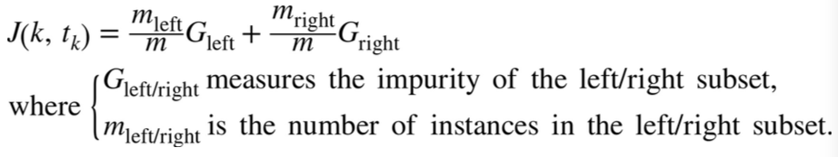
  + For regression CART splits by having lowest MSE
* Entropy
  + Measure of disorderness
  + A set’s entropy is zero when it contains instances of only one class
  + 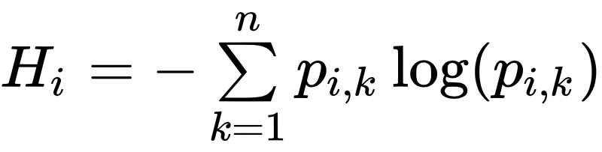
  + Both activation functions (Gini and Entropy) produce similar trees
    - However, Gini is faster
    - Gini = isolate the largest class from other classes
      * Used for numerical features
    - Entropy = find group that made up ~50% of the data
      * Entropy is a more balanced tree
      * Used for categorical ones
      * Take the log2(m) to find appropriate date
  + Entropy for Binary
    - 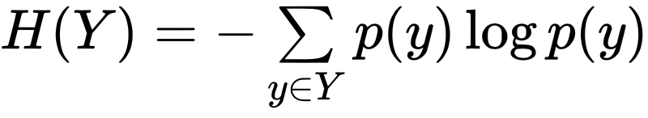
    - For binary entropy the log base is 2
    - Entropy = 1 when p = 0.5
      * 
  + Entropy for multi class uses natural log function?
* Information Gain
  + To measure the reduction in entropy of Y from knowing X
  + 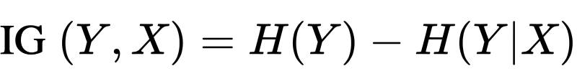
  + 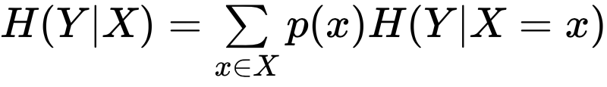
  + Use IG to decide the ordering of features in the nodes of a decision tree
  + 
  + See what the biggest IG and initially split on that
  + Computational Complexity
    - Finding optimal tree is NP-Complete
    - Traversing the tree takes O(log(m)) where m = features
      * Fast
    - Training comparing all features on all samples at each node O(nm log(m))
      * Slow down for large training set
* What makes a Good tree
  + Not too small or big
    - Small = might miss subtle distinctions in data
    - Big = may overfit the data with training examples
  + Occam’s Razor
    - Find simplest model that fits the observations
  + **Side Note** scaling don’t matter
* Regularization Hyperparameters
  + If left unconstrained, the decision tree will likely overfit the training data
    - Nonparametric model
  + Max depth = maximum depth of the decision tree
    - More depth may mean overfitting?
    - If overfitting decrease the max depth
  + Min Sample split
    - The minimum number of samples a node must have to split
  + Min sample leaf
    - The minimum number of samples a leaf node must have
  + Max leaf nodes
    - Maximum number of leaf nodes
  + Max Features
    - Maximum number of features that are evaluated for splitting
* Well balanced tree containing m entries will be log2(m)

Ensemble Learning

* 1000 random people vs 1 expert?
  + Averaging Reduces Variance
* Hard Voting
  + Use different classifiers
  + Output the class with the highest count of outputs
* Soft Voting
  + Use the probabilities
  + Highly confident votes play a bigger factor
    - Which results in normally being better
* Bootstrap
  + Repeatedly draw m bootstrap examples from the training sex
  + For each set of samples, train a model and then predict the labels.
  + Comines results of all bootstrap sets using majority voting
  + Bagging
    - Sampling is performed with replacement
    - Decrease variance of the base model without changing the bias
      * This works due to averaging
    - Helps when applied with an overfitting base model
  + Pasting
    - Sampling is performed without replacement
  + Out-of-bag Evaluations
    - Some instances will never get sampled, which can be used to calculate the score of the algorithm
* Random Forest
  + An ensemble of Decision Trees, generally trained with bagging
  + More randomness when growing trees
    - Instead of searching for the best feature with splitting node it searches for the best feature among a random set of features (subspaces)
    - Use a random threshold for each feature rather than search for the best possible threshold like regular decision tree
  + Has a higher bias, but a low variance
  + Only a random set of features is considered for splitting at each node
  + Extra trees
    - Makes tree more random by using a random threshold for each feature rather than search for the best possible threshold like regular decision tree
* Feature Importance
  + The important features are likely to appear closer to the root
    - It is possible to estimate the importance of the features by computing the average depth at which they appear across all trees in the forest

Boosting

* Ensemble method that an combine several weak learners into a strong learner
* The general idea of most boosting methods is to train predictors sequentially, each trying to correct its predecessor
* Boosting combines a weighted sum of many classifiers, thus it reduces variance
* Boosting vs Bagging
  + Similar to baggin, boostring combines a weighted sum of many classifiers, thus it reduces variance
  + Key difference
    - Boosting fit the tree to the entire training set, and adaptively weight the examples
    - Boosting tries to do better at each iteration, which reduces bias.
  + **Note** Boosting > Bagging > Decision Tree
* Why do Ensemble learning work?
  + Variance reduction
    - If training is independent it will always help to average an ensemble because it will reduce variance without affecting bias (Bagging)
  + Bias Reduction
    - For simple models, average of models can reduce bias substantially by increasing capacity, and control variance by fitting one component at a time (boosting)
* Adaboost
  + Methodologies
    - Select a base classifier
    - The relative weight of the misclassified training instance is then increased
    - Another classifier is trained using the updated weights
    - Repeat
  + 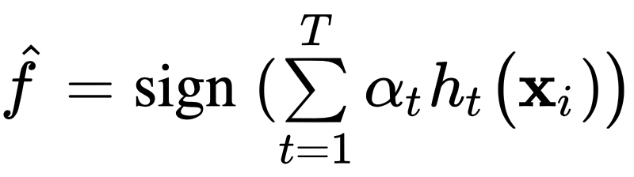
  + Gradient boosting
    - Uses residual error instead of the updated weights of previous
* Why use boosting?
  + Fast and simple to code
  + No hyper-parameter to tune except for number of iterations
  + No prior knowledge needed about the base classifier

Stacking

* Instead of using trivial function to aggregate the predictions of the ensemble, we train a model to perform the aggregation

Unsupervised learning

* Clustering
  + Process of grouping a set of objects into classes of similar objects
  + High intra-class similarity
  + Low inter-class similarity
* Distance measurement
  + Minkowski Metric
  + 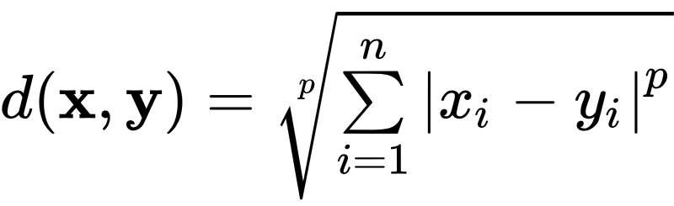
    - p = 1 = Manhattan Distance
    - p = 2 = Euclidean distance
    - “Sup” distance when p = infinity
* Hierarchical Clustering Algorithms
  + 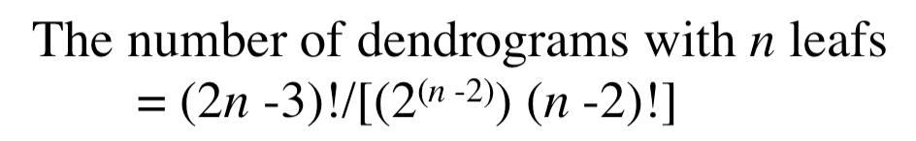
  + Bottom up
    - Starting with each item in its own cluster, find the best pair to merge into a new cluster. Repeat until all clusters are fused together
      * Greedy local optimal solution
    - Begin with distance matrix which contains the distance between every pair of objects and chose the best (shortest distance)
      * Continue to consider all possible merges (with new merge being one entitiy)
  + Computational Complexity
    - In first iteration all hac need to compute simliarity of pairs of m instances
      * O (m^2 * n)
    - Each computing of new distance is O(mn)
* Partitional algorithms
  + K-means (Algorithm)
    - Decide on a value for k
    - Initialize k cluster centers randomly
    - Decide the class memberships of the m objects by assigning them to the nearest cluster centroids
    - Re-estimate the k cluster centers, by assuming the membership found above are correct
    - If none of the m objects change membership in the last iteration, exit
  + K-means complexity
    - Distance is O(n) where n is dimension of vectors
    - Reassigning k is O(kmn)
    - Recomputing centroids is O(mn)
    - Reassigning and recomputing are each done for t iterations = O(tkmn)
  + Converging of K-means
    - Converge = when clusters no longer change
    - K-means is a part of Expectation maximization algorithm
      * Known to converge, but iterations could be large
* Evaluation of clustering
  + The intra cluster similarity is high
  + The inter cluster similarity is low
  + Depends on both the data representation and the similarity measure used
  + External
    - Quality measured by its ability to discover some of the hidden patterns in the data
  + Right number of clusters?
    - Unsolved problem, but we can measure by SSE
    - 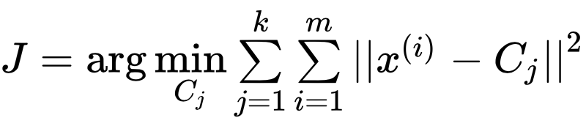
    - The SSE function will continue to decrease as the number of clusters increases
      * Resulting in zero when the number of clusters is the number of data points
    - When plotting the SSE function if you can see.an elbow cut in the SSE, this may suggest the right number of clusters for the data set, but this is just a speculation

Dimensionality Reduction

* PCA (Principal Component Analysis)
  + Identifies the hyperplane that lies closest to the data and then projects the data onto it
  + Selects the axis that preserves the maximum amount of variance, most likely lose less information than other projections.
  + Choose the right number of dimensions
    - Prefer to choose the number of dimensions to add up a sufficiently large portion of variance
    - Look at the elbow of for the explained variance as a function of dimensions
  + Incremental PCA
    - Split training set into mini-batches to feed into PCA at a time
      * A work around since PCA needs the whole training set to fit in memory to train
  + Kernal PCA (kPCA)
    - Perform complex non-linear project for dimensionality reduction
    - Good at preserving clusters of samples after projection
    - Useful for non-linear datasets
* Manifold Learning
  + Non-linear technique to reduce the dimensionality by modeling a manifold on which the training samples lie.
  + A d-dimensional manifold is a part of an n-dimensional space (where d < n) that locally resembles a d-dimensional hyperplane.
  + Manifold assumption
    - Most real-world high-dimensional dataset like close to a much lower-dimensional manifold
* Locally Linear Embedding (LLE)
  + Non-liner dimensionality reduction technique
  + Manifold Learning method that does not rely on projection
  + Methodology
    - Measures how each training sample linearly relates to its closest neighbors
    - Look for a low d-representation of training set when these local relationships are best preserved
    - Looks for k closest neighbors and puts weights and zero if not neighbor
      * Distance is not preserved on a large scale, but between samples the distance is locally well preserved
* Motivation and drawbacks
  + Motivation
    - Speed up a subsequent training algorithm
      * May even remove noise and redundant features
    - To visualize the data and gain insights on the most important features
  + Drawbacks
    - Information is lost, possibly degrading the performance of subsequent training algorithms
    - It can be computationally intensive
    - Adds more complexity to ML pipelines
    - Transformed features are hard to interpret

Artificial Neural Networks

* Artificial Neurons
  + One or more binary inputs and one binary output
* LTU (Linear Threshold Unit)
  + Inputs and output of numbers and input connection is associated with a weight
  + Computes a weighted sum of its inputs
* Perceptron
  + 
  + Training
    - 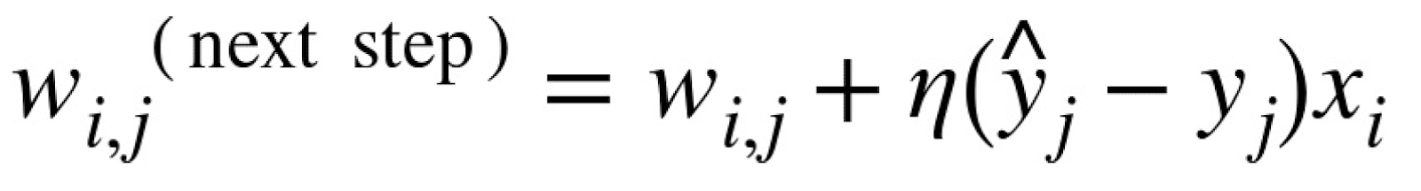
    - w = connection wegith between ith input neuron and jth output neuron
    - xi = ith input value of current training sample
    - y_hat is the output of the jth neuron
    - yj is target output of the jth output neuron
    - n is the learning rate
  + 
  + Activation function
    - 
    - Step function has a zero derivative and doesn’t work with GD
      * Use Logit function or other with well-defined non-zero derivative for GD
    - ReLU in hidden layers is faster to compute
      * Simple but outperformed by ELU
    - Logistic and Hyperbolic tangent function saturate at 1
      * Derivative is always non zero
    - Softmax is good for classification tasks
    - Regression tasks have no need for activation function.
    - ELU vs ReLU
      * It can take on negative values (average output of the neuron in any given layer is typically close to 0) **Helps alleviate the vanishing gradients problem
      * Always has a nonzero derivative which avoids the dying units issue that can affect ReLU
      * Smooth everywhere unlike ReLu where it abruptly jumps
    - Tanh
      * Useful if the output layer is a number between -1 and 1
    - Logistic activation function is also useful in the output layers when you need to estimate probability
      * Rarely used in hidden layers
    - Softmax
      * Useful in the output layer to output probabilities for mutually exclusive classes
  + Backpropagation
    - Forward pass
      * Feeds a training instance to the network and computes the output of every neuron
    - Backward Pass
      * Measures the network error, and computes the error contributions came from each neuron in previous hidden layer
    - Gradient Descent
      * Runs GD on all connection weights using the measured error
    - Notes
      * Have to replace the activation function to a logistic funcition
        + σ(z) =1 / (1 + exp(–z))
  + Fine-Tuning Network Hyperparameters
    - Number of layers
      * Real-world data often structured in a hierarchical way
        + So we may not need to always replace all layers
      * Better generalization if only changes hthe hidden layer
    - Number of neurons per layer
      * Funnel technique
      * Use more layer and more neuron than needed and do early stopping
        + Early Stopping: interrupt training when its performance on validation set starts dropping.
    - Type of activation function to use at each layer
    - Weight initialization logic
* Classic Perceptron vs Logistic regressor
  + Perceptron will converge only if the dataset is linearly separable and can’t estimate class probabilities
  + Logistic regression will converge to a good solution even if the dataset is not linearly separable and it will output class probabilities.
  + If you change the perceptron’s activation function to the logistic activation function and if you train it using GD then it becomes equivalent to Logistic Regression Classifier.

Training Deep Neural Networks

* DNN Configurations
  + Initialization
  + Activation
    - Poor choice of activation function can lead to vanishing/exploding gradient
    - ReLU is fast to compute, but suffer from dying: meaning not outputting anything but 0
      * To solve this u can use leaky ReLU
  + Normalization
    - Batch Normalization
      * Adds an operation before activation function
        + Normalize the inputs
        + Scale and shift the results

Optimal scale

* + - * Need *scale, offset, mean, and std
  + Regularization
    - Drop out
      * At every training step, every neuron has a probability p of being temporarily “dropped out”
      * The hyperparameter p is called the drop out rate
  + Optimization
    - * Momentum
        + Uses gradient as acceleration, not as speed
        + 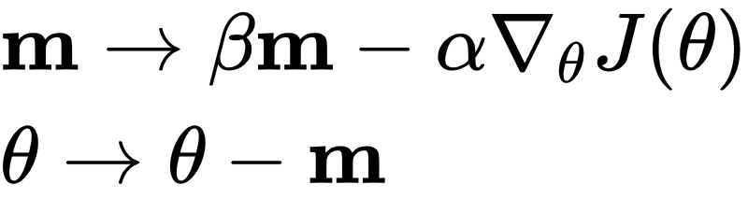
      * AdaGrad
        + Detects the bottom of valley early and corrects its direction to point a bit more toward global optimum
        + Achieve his by computing square of the gradients vector along the steepest dimensions
        + 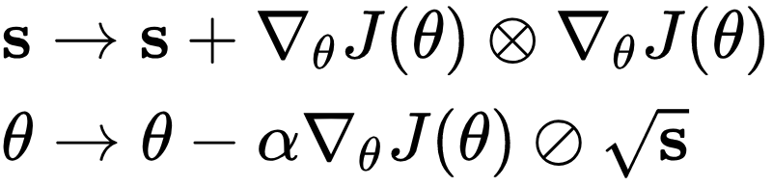
        + Never converging to global optimum
      * RMSProp
        + RMSProp fixed this by accumulating only the gradient from most recent iteration by using exponential decay if the first step
        + 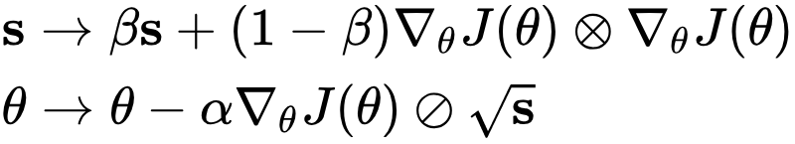
      * Adam
        + Combines momentum and RMSProp

Momentum = keeps track of exp decaying aveage of past gardients

RMSProp = keep track of an exponentially decaying average of past square gradients

* + Learning Rate
* Vanishing gradient problem
  + Gradients get smaller and smaller
    - They leave the connection weights virtually unchanged
  + Opposite is exploding gradient Problem

Convolutional Neural Network

* Convolutional Layers and Pooling layers (building blocks)
* Convolutional Layers
  + Neurons in the first convolutional layer are not connected to every pixel in the input image, but only to pixels in their receptive fields
  + Neuron in the second convolutional layer is connected only to neurons located within a small rectangle in the first layer
  + Concentrate on low-level features in the first hidden layer, then assemble them into higher-level features, and so on
  + Zero Padding
    - In order for a layer to have the same height and width as the previous layer, it is common to add zeros around the inputs.
  + Stride
    - Connect a large input layer to a much smaller layer by spacing out the receptive fields
  + Filter
    - With a A x A x C image and B x B x C filter
* You get an (A – B + 1) x (A – B + 1) x 1 activation map
  + Hyperparameters and Memory Requirements
    - Number of filters
    - Height and width
    - Strides, and padding types
    - Need a lot of RAM during training due to backward pass requires all intermediate values computed
* Pooling Layer
  + Subsample the input image in order to reduce the computational load, memory usage, and number of parameters
  + Each neuron in pooling layer is connected to the outputs of a limited number of neurons in the previous layer
  + Pooling layer has no weights. It just aggregates the inputs using max or mean function
* Architecture
  + Stack convolutional layers 🡪 pooling layer 🡪 convolution 🡪 pooling 🡪 … 🡪 top of the stack is the regular feedforward neural network to fully connect layers and final softmax.
    1. 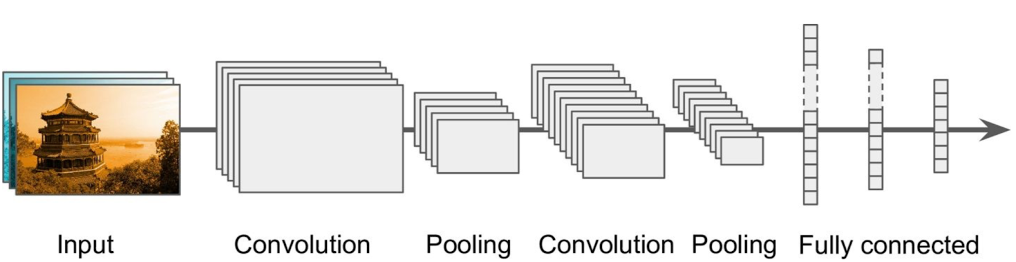
  + LeNet
    - Gradient-based learning applied to document recognition
  + AlexNet
    - Stack convolution layers directly on top of each other
  + GoogLeNet
    - Good local network topology (network within a network) and stack them on top of each other, and concatenate all filter outputs together depth-wise.
    - Have parallel filtering operations on the input from previous layer
    - 22 layers…stack efficient inception modules on top of each other
  + ResNet
    - More layers don’t mean better since it is harder to optimize
    - Deeper model should be able to perform at least as well as the shallow one
* Skip connections
  + Batch Norm after every convolutional layer
    - He Initalization
    - SGD (0.9) Momentum
    - Mini-batch size 256 and no drop out
* Advantage of CNN over DNN for image
  + CNN has fewer parameters than DNN, which makes it faster to train, reduce overfitting and requires less data
  + When CNN learns a particular feature, it can detect that feature anywhere on the image while DNN learns a feature in one location and can only detect in only that particular location. CNN can thus generalize better than DNN for image classification
  + DNN no knowledge of how pixels are organized. Doesn’t know special locality. CNN embed this prior knowledge

Reinforcement Learning

* Model-Based
  + Learn the model then use and update it often
* Value-Based
  + Learn the state or state-action value, act by choosing best action, and explore if necessary
* Policy-Based
  + Learn the stochastic policy function that maps state to action, act by sampling that policy
* Q-Learning (Value Based)
  + State-action value function: expected return when starting in s, performing a, and following pi (policy)
  + 
* Exploration vs Exploitations
  + Deterministic/greedy policy won’t explore all actions
    - No info about environment at the beginning. Should try all actions to find optimal
* Experience Replay
  + Current Q-network parameters determine next training examples (bad feedback loop)
  + Stores experience and creates mini-batches from them for training
* Policy Gradients (Policy-Based)
  + Problem with Q is that Q function can be complicated
  + 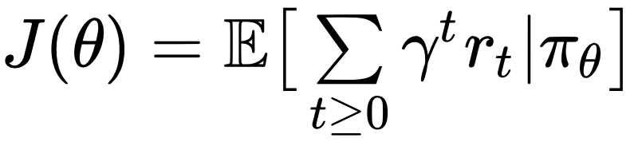
  + For each policy find the optimal using GRADIENT DESCENT (Ascent) on policy parameter theta
  + 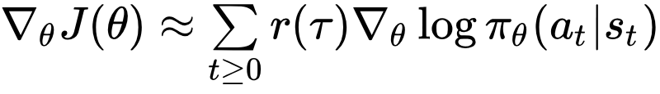
  + R(t) is high, push up the probabilities of the actions seen
  + R(t) is low, push down the probabilities of the actions seen
* PG vs DQN
  + Pros (for PG)
    - Messy world. If Q too hard to learn, DQN may fail while PG will still learn a good policy
    - Speed (Faster convergence)
    - Stochastic (PG is capable of learning stochastic policies while DQN can’t)
    - Continuous actions (easier to model on continuous space)
  + Cons
    - Data (Sample. Need more data)
    - Stability (Less stable for training process)
    - Credit assignment (Poor assignment to state

QUIZ 6 (Okay)

1. What is approximate depth of Decision Tree without restriction on training set with 1,000 examples
   * + - 1. Log2(m) 🡪 log2(1,000) around 10
2. Is a node’s Gini Impurity Lower or greater than its Parent’s
   * + - 1. It is generally Lower
     1. Cart splits by which will result in the lowest sum of gini index of children
3. Calculate the Gini Impunity index for a set of 100 instaence from 4 classes: 10 from 1 20 from 2 30 from 3 and 40 from 4
   1. (1 – ((10/100)^2 + (20/100)^2 + (30/100)^2 + (40/100)^2)) = 7/10
4. Which statement is False when comparing Gini and Entropy as measure of disordersness
   1. Gini tends to produce more balanced tree
   2. **Now lets restate**
   3. What are the true statements
      1. Entropy is slightly faster to compute
      2. Both Gini and entropy produce similar decision tree
      3. Entropy tends to isolate most frequent class in its own branch
      4. Entropy tends to produce a more balanced tree
5. Suppose you are building decision tree model, which split a node on the attribute has the highest information gain.   
   
   1. Outlook
      1. You want the least amount of entropy possible

Quiz 7 Boosting and Clustering Methods (Okay)

* + - 1. If your Adaboost ensemble overfits that training data, what hyper parameter should you tweak?
         1. Learning Rate (why not weight)?
      2. Given the update function of the example weight, what happen to the weight when the base classifier returns label -1 to +1 example

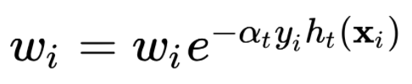

* + - * 1. Increase exponentially
      1. In Hierarchical Clustering, which step takes the highest time complexity
         1. Creating the distance table of examples all pairs of individual examples
      2. T/F: K-means will always give the same results regardless of the initialization of the centroids
         1. False
      3. What is required by K-means
         1. Defined distance metric
         2. Number of clusters
         3. Initial guess as to cluster centroids

Quiz 8 Artificial Neural Networks (Okay)

1. Which statement is NOT a reason why ANNs will have more impact today
   1. Theoretical limitations of ANN turns to be a big threat to its success. No this is wrong lol
   2. What is a reason why ANN will have more impact?
      1. Huge quantity of data available to train
      2. Increasing computing power
      3. Development of improved training algorithms
      4. A virtuous circle of funding and progress
2. Why the XOR classification problem can’t be solved using a single Perceptron?
   1. Because the Perceptron can only make predictions on linearly separable data
3. What is the dimensionality of W[2] in z[2] = W[2]A[1] + b[2]   
   
   1. 1 x 4
4. While training the MLPs using back-propagation, the connections weights are updated in which iterative step?
   1. Gradient Descent
5. Which activation function doesn’t work well with GD
   1. Step function
      1. Because Step function has a zero derivative

Quiz 9: Deep Neural networks (Okay)

1. Consider the following Deep Neural Network, what is dimensionality of Z[2] for the case of batch of m training examples  
   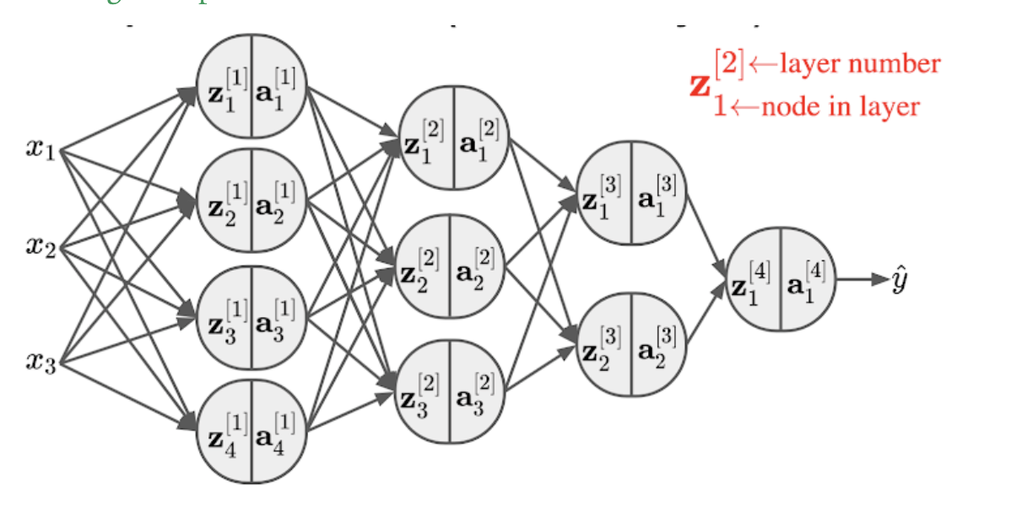
   1. 3 x m (ASK)
2. Which reasons below is the reason ELU is used instead of Leaky ReLU
   1. ELU fixes the “dying ReLU” problem, as it doesn’t have zero-slope parts
3. Which of the following is an effective regularization technique for deep neural networks
   1. Dropout
4. Momentum Optimization uses gradients as acceleration which may help roll past local optima, but is there any issue it would cause
   1. It might roll past the global optimum and makes training error diverge
5. Which learning rate schedule is recommended for deep neural network
   1. None (out of Performance, Exponential, Power)
   2. 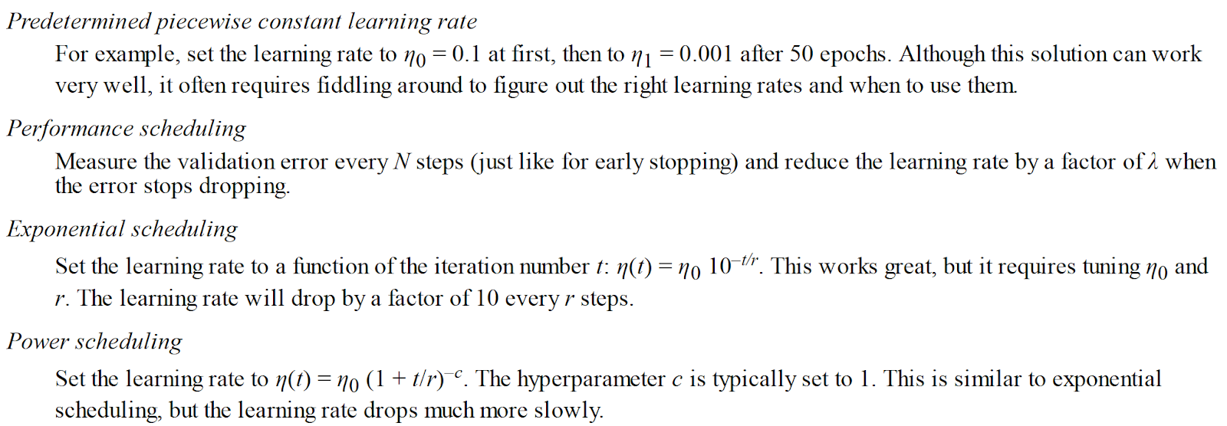

Quiz 10 Convolutional Neural Networks (Okay)

1. If you apply (taking dot product) a 4x4x3 filter to an image of 32x32x3. How many float operations (excluding adding the bias term) would be needed to compute one node of the next layer
   1. 4 x 4 x 3 = 48
      1. Use the filter not the image
2. One the same problem above, how many filters would you need to ensure that the depth of the next layer to be 10
   1. 10 because it make a A x A x 1
3. How many parameters/weights does the network need to learn for the pooling layer
   1. 0 NONE
4. Why use 1x1 convolution filter
   1. Used to reduce depth to a lower number while preserving the spatial dimensions
      1. Preserves spatial dimensions, reduces depth
      2. Projects depth to lower dimensions (combination of feature maps)
5. What is the main reason why adding more layers doesn’t necessarily mean better network
   1. It makes the network harder to optimize